Class Management Each of my classes has their own Edmodo page where deadlines, rubrics, quiz/test notices, review sheets, files, links, answer keys, polls and interactions are posted. Each class needs the Edmodo group code (see our website http://luposphysics.weebly.com/) to create a profile at the beginning of the year. Write your username and passcode in a safe place in case you forget it. Turn notifications ON for the mobile app to stay up to date.
Grading Policy I use a total points system to calculate my quarter grades. I also use PowerSchool comments to communicate a variety of information so please be sure to view those regularly. The majority of your grade will come from assessments (70% summative, 25% formative) and only 5% from homework.
Semester grades will also include mid term and final examination grades. Each of these will be worth 10% per semester. Seniors that earn above a 90 for the year will be exempt from the final exam.
Q1 (Aug – Nov) | Motion, Forces, Gravity
Q2 (Nov-Jan) | Energy, Work, Power, Momentum
Q3 (Jan – Mar) | Circular Motion, Electrostatics, Circuits
Q4 (Mar – June) | Harmonics, Waves, Sound, Light
Topics* to be covered:

*topics may vary based on teacher discretion
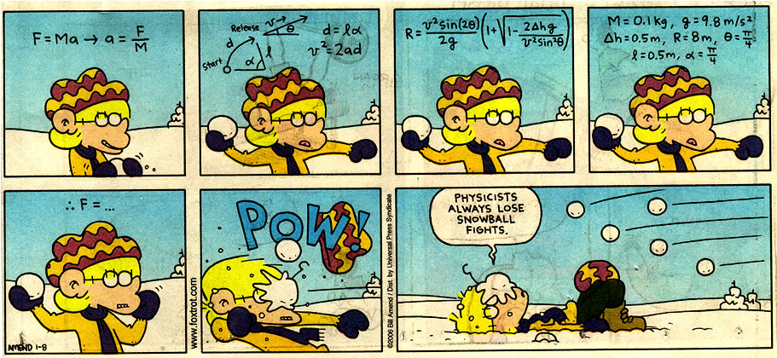
Homework Policy Homework is assigned several times per week. It may consist of a reading and notetaking section, a set of practice problems, a set of worksheets, a written summary to follow up on a class concept or an Edmodo post. Homework is due the day after it is assigned unless otherwise noted. Homework is selected to precisely target concepts covered in class for reinforcement and comprehension. Homework is assigned after a problem solving methods are demonstrated in class. Students are expected to use their resources (notes, textbook, web resources) to assist them when they work independently on homework. Homework is the opportunity for students to self-determine their specific strengths and weaknesses surrounding our skills and concepts. Students that choose not to complete homework practice struggle significantly on assessments in Physics.

Notecard Students will be allowed to build a note card (4x6 max) of constants, conversions, diagrams, formulas, units, etc. as year progresses for use on all assessments and semester exams. Students may not share notecards. We will follow the school policy for makeup work depending on the number of days for an absence – if a study is absent the day of a unit test review they are expected to take the test as scheduled.
Contact: Email: lupoj@region10.ct.org (preferred contact)
Phone: 860-673-0423 x 15205
Class Webpage: http://luposphysics.weebly.com/conceptual-physics-320.html
Several useful web resources are embedded here for student use!
Assessments:
Student learning will be assessed in two ways. Formative Assessments will be shorter and more frequent within a unit of study to provide me with a way to determine if the student is ‘getting it’ or needs relearning/reteaching. These assessments could include short answer questions, diagrams, true & false questions, fill-in questions & quick computations. Formative Assessments are graded. Formative Assessments can be retaken for qualified students that don’t meet the assessment goal. Summative Assessments come at the conclusion of a unit of study and represent the end knowledge and skills the student acquired throughout the unit. Unit tests will include a section of objective questions (conceptual and computational multiple choice) and subjective questions (open ended applications of skills and content). Review sheets are posted for unit tests and in class review exercises take place prior to a unit test.
Classroom Expectations and Student Responsibilities:
- Be on time and ready to learn. Bring your notebook, textbook, pencil, notecard and scientific calculator daily.
- Keep your cell phone in your backpack unless specified for a learning activity.
- Participate constructively and be an active learner. Ask questions about what you don’t understand and when you need clarification – many times others may have a similar question.
- Be courteous to your peers and using positive encouragement and constructive feedback.
- Use provided resources to support your learning – your notes, homework practices, chapter readings and web resources that we utilize in class are there to expand your skills and knowledge – USE THEM!
- Do your best on your assignments, especially your homework. Balance your time wisely so that you have sufficient time to practice.
- Be trustworthy and maintain academic integrity. Cheating and plagiarism are not tolerated.
- Use remaining class time for assigned practice and topic discussion – refrain from lining up at the door to ‘wait for the bell’.
- Get extra help outside of class when you need it, use my posted schedule to find a time.
- Help keep the classroom clean – trash in the trashcan not left on your desk or the floor.
- Minimize requests for lav/locker passes– wait for a transition rather than during a learning activity.
- Help keep your parents and guardians in the loop by communicating with them what you’re learning and how you’re progressing.
- Only touch lab equipment when instructed to do so. Don’t open drawers or cabinets without permission.

